ELECTRIC POTENTIAL.

Lecture #9

Electric Potential

Capacitance Recall that a conservative force is one in which the work done on a particle that moves between two points depends only on the two points and not on the path followed. With this property, we were able to define a potential energy that could be associated with the force involved. Similarly, we can define a conservative vector field as a field that generates a conservative force. This allows us to introduce the concept of a potential for the field, in direct analogy to the potential energy for a force. Specifically, we define the potential, ϕ, of a vector field, ƒ, by the relation
(17)
Notice that the potential is a scalar quantity. Instead of three (or more) equations to solve, there is only one. It is this fact that makes the potential easier to work with in most calculations. Also, just as with potential energy, the potential of a field is not an exact quantity. Instead, it only has physical meaning when changes in the potential are considered. In fact, the field potential is related to the potential energy in exactly the same way the field is related to the force (up to a change in sign), i.e., by
 | 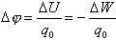 | (18)

where q₀ is the charge associated with the field under consideration.

Equipotential Surfaces
When ΔW = 0, we have a special situation. By equation (18), we have that Δϕ = 0. The locus of points which have Δϕ = 0 is called an equipotential surface. All equipotential surfaces are at right angles to the field lines everywhere. This fact makes it very easy to find the equipotential surfaces once the field lines are known (or vice versa).
Example:
Find the equipotential surfaces for two charges of equal magnitude but opposite signs separated by a distance a.
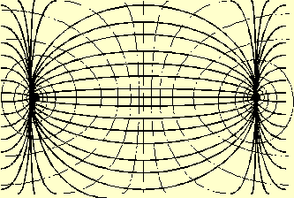
When dealing with electromagnetism, it is common to denote the electric potential by the symbol, V, which has units of volts. In terms of more fundamental units, a volt is defined as
1 volt = 1 joule / coulomb.
Since electromagnetism is a long range force, it is common to take the reference point, V_{a}, to be located at infinity, so that V_{a} = 0. When this choice is made, then ΔW is just the work required to move a test charge in from infinity to the point in question. Notice though, that there is no requirement that V_{a} be at infinity; occasionally, the inherent symmetry of the problem will dictate another choice for the location of V_{a}. An example of this will be given later.
Let us now consider a single point charge. What is the potential due to this charge? Recall that the electric field for the charge is given by
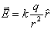
Then we find, for a point charge
 | 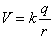 | (19)

If we have a collection of discrete charges. then the potential for the system is just the sum of the individual potentials:
 | 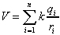 | (20)

Example:
What is the potential of an electric dipole?
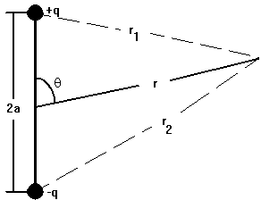
Assume that the two charges have a magnitude of q and are separated by a distance 2a. For simplicity, place the center of the dipole at the origin. Then for a point at a distance r from the origin and at an angle θ from the dipole direction, we have
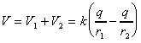
where
and
In the limit r >> 2a, this reduces to
 | 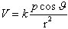 | (21)

where p = 2aq is the electric dipole moment. Notice that the dipole is strongest along it's axis of orientation (θ = 0, π) for any radius.
The electric dipole moment is found in many molecules and atoms. It is formed when the distribution of the charge is not symmetric about the physical distribution of the object. In these cases, there is an excess of positive charge at one side, and negative charge at the other. When the object is given a dipole moment by an external electric field, then the dipole is known as an induced electric dipole moment. When the external field is removed, the induced dipole moment will also disappear.
Example:
What is the potential of a spherical shell of radius R with a charge Q?
For a spherical charge density, the electric field is given by
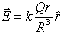
Since we are working with a shell instead of a solid sphere, this is split into three sections: r > R, r = R, and r < R. Let us look at each one separately.
Case 1: r > R.
In this case, the electric field is given by
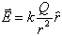
Since this is the electric field of a point charge, we have already found the potential. It is
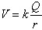
Case 2: r < R.
In this case, the electric field is zero (all of the charge is on the surface of the shell). So we see that
V_{b} - V_{a} = 0 V_{b} = V_{a} = const
where the constant is yet to be determined.
Case 3: r = R.
This case is what is called a boundary condition. Since V is a continuous function, the values of V(r>R) and V(r<R) must be equal at r = R. Looking at V(r>R), we see that, at r = R, we have
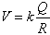
Thus, we see that the unknown constant for case 2 is just
Summing all this up, we have that, for a spherical shell, the potential is given by
 | 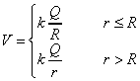 | (22)

In this example we can see an interesting phenomenon. We can write Q as a density times a volume. As the volume is decreased, the density will increase. This causes a buildup of large potentials and fields at sharp points and corners. If the charge buildup is large enough, then the electric field generated by the charge will cause the air around it to ionize. This effect is known as a corona discharge and the best known example of it is lightning during a thunderstorm.
Example:
What is the potential of an infinite line charge?
The change in the voltage is given by
ΔV = - E · Δl.
The electric field of an infinite line charge is given by
 | 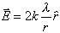 | (23)

where λ is the charge per unit length. Taking Δl = Δr r and summing over all the Δr, we get
where V_{a} is our reference potential. Recall that earlier I said that it is common to take the reference potential, V_{a}, to be located at infinity, so that V_{a} = 0. In this case, if we take r = ∞, instead of getting V_{a} = 0 (as we would want) we would find V_{a} = ∞. Thus to have V_{a} = 0, we must take some arbitrary distance r = a. Then the potential becomes
 | 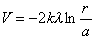 | (24)

Energy of the Electric Potential
Since the electric potential is defined in terms of the potential energy, we can use our knowledge of the electric potential to determine the energy stored in the electric field. In general this is given by
Example:
How much energy is required to move an electron through a potential difference of 1 V?
Using the relation between energy and electric potential we have
This combination shows up so frequently in particle physics that it has been given it's own designation, the electron volt, or eV. We frequently talk about particles with kinetic energies in the thousands, millions, billions or even trillion eV, so these are denoted keV, MeV, GeV and TeV respectively

